

To: Intel Corporation, Head of Marketing

From: Kelly Services Inc.

Date: June 8, 2014

Subject: Staffing Solutions for Tomorrow’s Workplace

Through innovations and forward-thinking, Intel has pioneered the rapidly growing tech industry. This has earned Intel a well-respected and trusted reputation when it comes to the manufacture of computing and communications products. The ‘Services’ in Kelly Services Inc. is what could help differentiate Intel from the rest of its competitors. Manufacturing reliable hardware is of course the basis of any successful tech company; excelling at providing high quality support and service in addition to these great products is what propels a company up the Fortune 500 ladder.

Kelly Services is a provider of world-class staffing solutions. Just last year our company provided employment to over 540,000 employees and had revenues exceeding $5.4 billion. We provide staffing through temporary, temporary-to-hire, and direct-hire basis. In addition we provide outsourcing, consulting services, and even offer access to virtual employees.

In this day and age, finding qualified and proven applicants becomes a grueling and time consuming process. Kelly Services Inc. helps alleviate this burden by providing its partners with the most qualified individuals for the positions that need to be filled. Kelly prides itself on providing professional employees for the professional workplace.

Let Kelly do the work for you!

* Kelly arduously goes over each and every resume of applicants in order to find the best candidate for the position
* All prospective hires are screened and interviewed by our experienced Staffing Agents
* All resume qualifications are validated through tests in order to verify applicant abilities

When you direct hire through our agency, you are guaranteed quality employees. Our 68 years of staffing solutions proves it.

In the modern age of business, computing and communications go hand-in-hand. The fact that Intel already excels in providing both puts the company in a prime position to benefit from employment solutions that make use of them! Virtual employees are quickly becoming commonplace in today’s workforce, and what better industry is there for them to shine than in the tech industry?

Through Kelly’s recent partnership with global online workplace provider oDesk, we are glad to be able to offer our clients access to virtual employees. Kelly understands the hesitation that may come with adopting such a new and revolutionary method of staffing, but we can assure you that the benefits far outweigh the concerns. Some highlights of the quickly growing virtual employment sector include:

* Reducing office space and real estate expenses
* Providing greater flexibility for workers
* A greener work environment; better image for business
* Positioning employees at the forefront of customer and business partner interaction

As you can see in the graph below, it has been shown that both virtual employees and the companies they work for found virtual employment to be overwhelmingly liberating and productive in comparison to any potential isolation caused by working virtually. Happy and productive employees have a significant positive impact in the success of a company.

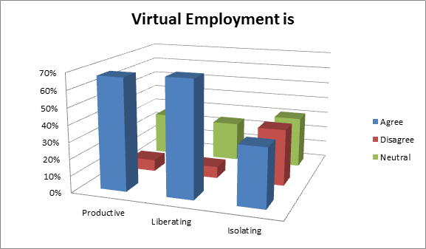(Gaille, 2013)

With our combined century of experience, a partnership between our companies would be extremely formidable to the competition, to say the least. Intel can further its commitment to supporting its products by allowing us to jointly work together in order to achieve and offer support in world class fashion. Simply put, Kelly Services Inc. founded the staffing industry in 1946, and we continue to pioneer it to this day. 98% of Fortune 100 companies are Kelly clients; shouldn’t you be one too?

References

Gaille, B. (2013). *13 Important Virtual Workplace Statistics and Trends*. Retrieved from <http://brandongaille.com/13-important-virtual-workplace-statistics-and-trends/>

Global Workplace Analytics (2012). *Latest Telecommuting Statistics*. Retrieved from <http://www.globalworkplaceanalytics.com/telecommuting-statistics>

Intel Corporation (2014). Intel Company Overview. Retrieved from <http://www.intel.com/content/www/us/en/company-overview/company-overview.html>

Intel Corporation SWOT Analysis (2014). *Intel Corporation SWOT Analysis*, 1-9. Retrieved from <http://proxy.devry.edu/login?url=http://search.ebscohost.com/login.aspx?direct=true&AuthType=url,cookie,ip,uid&db=bth&AN=94922054&site=eds-live>

Kelly Services, Inc. SWOT Analysis (2013). *Kelly Services, Inc. SWOT Analysis*, 1-8.

Retrieved from <http://proxy.devry.edu/login?url=http://search.ebscohost.com/login.aspx?direct=true&AuthType=url,cookie,ip,uid&db=bth&AN=85414942&site=eds-live>

Kelly Services, Inc. (2014). About Us. Retrieved from

[http://www.kellyservices.us/US/About-Us/#.U4qRgCgVdPU](http://www.kellyservices.us/US/About-Us/%23.U4qRgCgVdPU)

Thompson, C. (2011). The Risk and Benefits of Virtual Workforces. *Aon One*. Retrieved from<http://one.aon.com/risk-and-benefits-virtual-workforces>

Welch, S. (2013). Kelly makes deal for access to virtual employees. *Crain's Detroit Business, 29*(51), 0016. Retrieved from [http://eds.a.ebscohost.com.proxy.devry.edu/eds/detail?sid=7345bc2e-0ead-4b5d-a066-6ae84be31086%40sessionmgr4002&vid=3&hid=4213&bdata=JkF1dGhUeXBlPXVybCxjb29raWUsaXAsdWlkJnNpdGU9ZWRzLWxpdmU%3d#db=heh&AN=93390360](http://eds.a.ebscohost.com.proxy.devry.edu/eds/detail?sid=7345bc2e-0ead-4b5d-a066-6ae84be31086%40sessionmgr4002&vid=3&hid=4213&bdata=JkF1dGhUeXBlPXVybCxjb29raWUsaXAsdWlkJnNpdGU9ZWRzLWxpdmU%3d%23db=heh&AN=93390360)